CHAPTER 8
SAMPLING DISTRIBUTIONS

SECTION EXERCISES
8.1 d/p/m The sampling distribution of a statistic is a probability distribution of the sample statistic for all possible samples of that particular size. Therefore, a sampling distribution is a probability distribution.
It is for a statistic (which is a random variable) with a sample size specified.

8.2 d/p/m The standard deviation of a sampling distribution is referred to as the standard error.

8.3 c/a/e The population proportion, π = 180/1000 = 0.18; sample proportion, p = 150/1000 = 0.15; sample size, n = 1000.

8.4 c/a/d
a. Let x = number of TV sets owned. The probability distribution is given below.
x: | 1 | 2 | 3 | 4
P(x): | 0.2 | 0.4 | 0.2 | 0.2
μ = 1(0.2) + 2(0.4) + 3(0.2) + 4(0.2) = 2.4
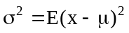 = (1 - 2.4)²(0.2) + (2 - 2.4)²(0.4) + (3 - 2.4)²(0.2) + (4 - 2.4)²(0.2) = 1.04
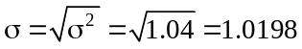

b. and c.
 |  | probability of
sample | = mean of this sample | selecting this sample
Allen, Betty | (2 + 1)/2 = 1.5 | 1/10
Allen, Chuck | (2 + 3)/2 = 2.5 | 1/10
Allen, Dave | (2 + 4)/2 = 3.0 | 1/10
Allen, Eddie | (2 + 2)/2 = 2.0 | 1/10
Betty, Chuck | (1 + 3)/2 = 2.0 | 1/10
Betty, Dave | (1 + 4)/2 = 2.5 | 1/10
Betty, Eddie | (1 + 2)/2 = 1.5 | 1/10
Chuck, Dave | (3 + 4)/2 = 3.5 | 1/10
Chuck, Eddie | (3 + 2)/2 = 2.5 | 1/10
Dave, Eddie | (4 + 2)/2 = 3.0 | 1/10

d. The sampling distribution of the mean (n = 2) is:
: | 1.5 | 2.0 | 2.5 | 3.0 | 3.5
P(): | 0.2 | 0.2 | 0.3 | 0.2 | 0.1
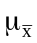= 1.5(0.2) + 2(0.2) + 2.5(0.3) + 3(0.2) + 3.5(0.1) = 2.4
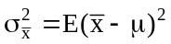 = (1.5 - 2.4)²(0.2) + (2 - 2.4)²(0.2) + (2.5 - 2.4)²(0.3) + (3 - 2.4)²(0.2)
+ (3.5 - 2.4)²(0.1) = 0.39 and 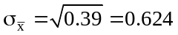

e. Repeating parts (b) through (d) using n = 3.
 |  | probability of
sample | = mean of this sample | selecting this sample
A,B,C | (2 + 1 + 3)/3 = 2 | 1/10
A,B,D | (2 + 1 + 4)/3 = 7/3 | 1/10
A,B,E | (2 + 1+ 2)/3 = 5/3 | 1/10
A,C,D | (2 + 3 + 4)/3 = 3 | 1/10
A,C,E | (2 + 3 + 2)/3 = 7/3 | 1/10
A,D,E | (2 + 4 + 2)/3 = 8/3 | 1/10
B,C,D | (1 + 3 + 4)/3 = 8/3 | 1/10
B,C,E | (1 + 3 + 2)/3 = 2 | 1/10
B,D,E | (1 + 4 + 2)/3 = 7/3 | 1/10
C,D,E | (3 + 4 + 2)/3 = 3 | 1/10

The sampling distribution of the mean (n = 3) is:
: | 5/3 | 2 | 7/3 | 8/3 | 3
P(): | 0.1 | 0.2 | 0.3 | 0.2 | 0.2
= 5/3(0.1) + 2(0.2) + 7/3(0.3) + 8/3(0.2) + 3(0.2) = 2.4
= (5/3 - 2.4)²(0.1) + (2 - 2.4)²(0.2) + (7/3 - 2.4)²(0.3) + (8/3 - 2.4)²(0.2)
+ (3 - 2.4)²(0.2) = 0.1733
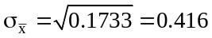
The larger sample size does not affect the mean of the sampling distribution. The standard error of the sampling distribution gets smaller when the sample size is increased.

8.5 c/a/d
a. μ = 1(0.5) + 2(0.5) = 1.5
= (1 - 1.5)²(0.5) + (2 - 1.5)²(0.5) = 0.25
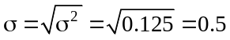

b. and c.
 |  | probability of
sample | = mean of this sample | selecting this sample
1,1 | (1 + 1)/2 = 1.0 | 1/4
1,2 | (1 + 2)/2 = 1.5 | 1/4
2,1 | (2 + 1)/2 = 1.5 | 1/4
2,2 | (2 + 2)/2 = 2.0 | 1/4

d. The sampling distribution of the mean (n = 2) is:
: | 1.0 | 1.5 | 2.0
P(): | 0.25 | 0.50 | 0.25
= 1(0.25) + 1.5(0.50) + 2(0.25) = 1.5
= (1 - 1.5)²(0.25) + (1.5 - 1.5)²(0.50) + (2 - 1.5)²(0.25) = 0.125
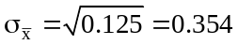

e. Repeating parts (b) through (d) using a sample of size n = 3.
 |  | probability of
sample | = mean of this sample | selecting this sample
1,1,1 | (1 + 1 + 1)/3 = 1 | 1/8
1,1,2 | (1 + 1 + 2)/3 = 4/3 | 1/8
1,2,1 | (1 + 2 + 1)/3 = 4/3 | 1/8
1,2,2 | (1 + 2 + 2)/3 = 5/3 | 1/8
2,1,1 | (2 + 1 + 1)/3 = 4/3 | 1/8
2,1,2 | (2 + 1 + 2)/3 = 5/3 | 1/8
2,2,1 | (2 + 2 + 1/3 = 5/3 | 1/8
2,2,2 | (2 + 2 + 2)/3 = 2 | 1/8

The sampling distribution of the mean (n = 3) is:
: | 1 | 4/3 | 5/3 | 2
P(): | 1/8 | 3/8 | 3/8 | 1/8
= 1(1/8) + 4/3(3/8) + 5/3(3/8) + 2(1/8) = 1.5
= (1 - 1.5)²(1/8) + (4/3 - 1.5)²(3/8) + (5/3 - 1.5)²(3/8) + (2 - 1.5)²(1/8) = 0.0833
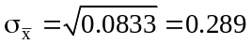
The larger sample size does not affect the mean of the sampling distribution. The standard error of the sampling distribution gets smaller when the sample size is increased.

8.6 c/a/d Let x the amount paid by individual visitors. The probability distribution of x is:
x | $0 | $1
P(x) | 0.70 | 0.30
a. The mean and standard deviation of x.
μ = 0(0.7) + 1(0.3) = 0.30
= (0 - 0.3)²(0.7) + (1 - 0.3)²(0.3) = 0.21 and 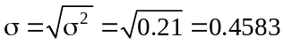

b. The sampling distribution of the mean (n = 3).
 |  | probability of
sample | = mean of this sample | selecting this sample
0,0,0 | (0 + 0 + 0)/3 = 0 | 0.343
0,0,1 | (0 + 0 + 1)/3 = 1/3 | 0.147
0,1,0 | (0 + 1 + 0)/3 = 1/3 | 0.147
0,1,1 | (0 + 1 + 1)/3 = 2/3 | 0.063
1,0,0 | (1 + 0 + 0)/3 = 1/3 | 0.147
1,0,1 | (1+ 0 + 1)/3 = 2/3 | 0.063
1,1,0 | (1 + 1 + 0)/3 = 2/3 | 0.063
1,1,1 | (1 + 1 + 1)/3 = 1 | 0.027

The sampling distribution of the mean (n = 3) is:
: | 0 | 1/3 | 2/3 | 1
P(): | 0.343 | 0.441 | 0.189 | 0.027
= 0(0.343) + 1/3(0.441) + 2/3(0.189) + 1(0.027) = 0.30
= (0 - 0.30)²(0.343) + (1/3 - 0.30)²(0.441) + (2/3 - 0.30)²(0.189)
+ (1 - 0.30)²(0.027) = 0.07, and 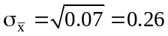

8.7 c/a/m
a. 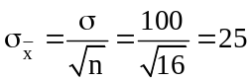 b. 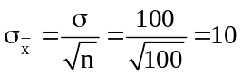
c. 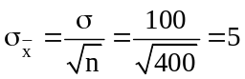 d. 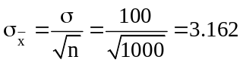

8.8 c/a/m Since x is normally distributed with μ = 200 and σ = 20, is normally distributed with
= μ = 200 and 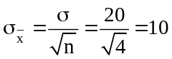.
a.
b.
= 0.9987 - 0.1587 = 0.8400
c. 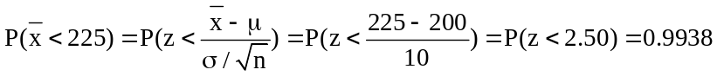

8.9 c/a/m Since x is normally distributed with μ = 80 and σ = 10, is normally distributed with
= 80 and 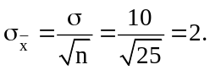
a.
b.
c. 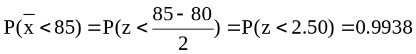

8.10 c/a/m Given μ = 62, σ = 15, n = 36, and 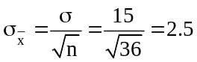
a. 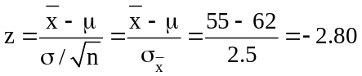 b. 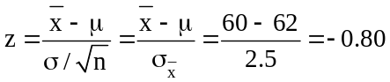
c. 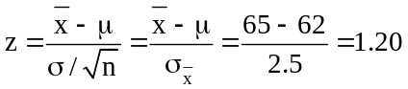 d. 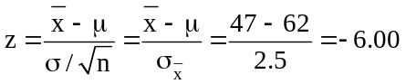

8.11 c/a/m Given μ = 62, σ = 15, n = 36, and
P( < 65) = P(z < 1.20) = 0.8849

P(55 ≤ ≤ 65) = P(-2.80 ≤ z ≤ 1.20) = 0.8849 - 0.0026 = 0.8823

8.12 c/a/m Given μ = $190,000, σ = $50,000, n = 40, and 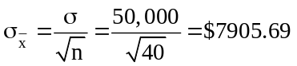
P( > $200,000) = P(z >1.26) = 1.0000 - 0.8962 = 0.1038

8.13 c/a/m Given μ = 100 horsepower with σ = 10, n = 4, and 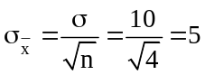
P(Crane not performing properly) = P( < 380/4) = P( < 95) = P(z < (95-100)/5) = P(z < -1.00) = 0.1587. The engineer's concern appears to be justified in that there is a good chance that the crane will not perform properly.

8.14 c/a/m Given that μ = 80, σ = 20, n = 100, then 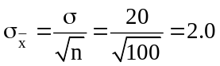
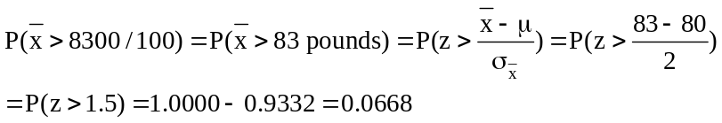
Thus, 6.68% of the flights will require an extra 500 pounds of fuel.

8.15 p/a/m Let x = consumption of wattage of drill with μ = 295 and σ = 12 watts. Samples of size 9 are selected, where the distribution of , from the central limit theorem, has μ = 295 and
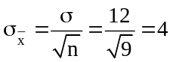.
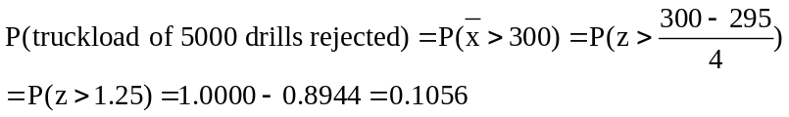
Thus, there is a 10.56% chance the truckload is rejected.

8.16 p/a/m Let x = tensile strength in pounds per square inch, x is normally distributed with μ = 10,000 and σ = 800. Therefore, is normally distributed with 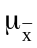 = 10,000
and 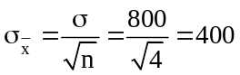
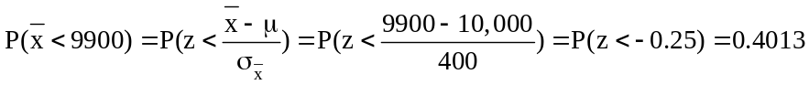

8.17 p/a/m Given x is exponentially distributed with μ = σ = 3.5. Since n = 36, is approximately normally distributed by the central limit theorem with = 3.5 and
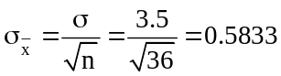

8.18 p/a/m Given x is normally distributed with μ = 80 and σ = 15. The sample size is n = 10 and the underlying distribution is normal, so is normally distributed with = 80 and
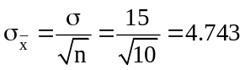

8.19 p/a/m Since n = 50, is approximately normally distributed by the central limit theorem with
= 5.5 and 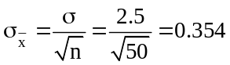
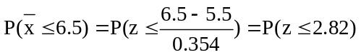= 0.9976
If the sample size had been only n = 8 patients, the central limit theorem would not apply. The solution would have required the assumption that the underlying population is normally distributed.

8.20 p/a/m Since n = 30, is approximately normally distributed by the central limit theorem with
= 45 and 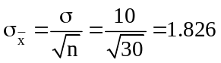
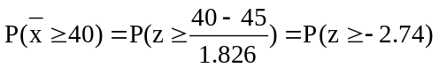= 1.0000 - 0.0031 = 0.9969

8.21 c/a/m With π = 0.46 and n > 30 (i.e., n ≥ 31), nπ ≥ 14.26 and n(1 - π) ≥ 16.74. Since both nπ and
n(1 - π) are ≥ 5, the sampling distribution of p will be approximately normally distributed with a mean of π = 0.46 and a standard error of no more than
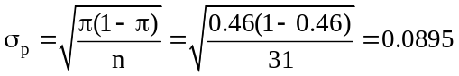

8.22 c/a/m With π = 0.60 and n = 40, nπ and n(1 - π) are both ≥ 5. The sampling distribution of p will be approximately normally distributed with mean = π = 0.60 and a standard error of
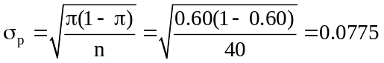

8.23 c/a/m With π = 0.40 and n = 300, both nπ and n(1 - π) are ≥ 5. The sampling distribution of p will be approximately normally distributed.
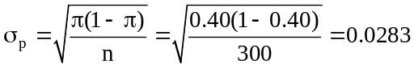
a. 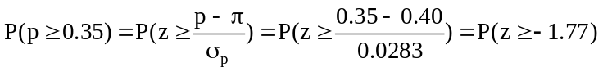
= 1.0000 - 0.0384 = 0.9616
b.
= 0.7611 - 0.2389 = 0.5222
c. 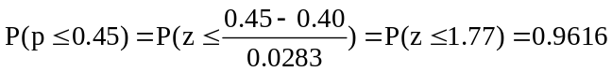

8.24 c/a/m With π = 0.6 and n = 200,both nπ and n(1 - π) are ≥ 5, and the sampling distribution of p will be approximately normally distributed.
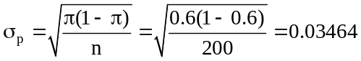
a. 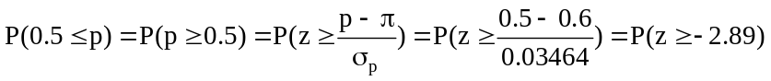
= 1.0000 - 0.0019 = 0.9981
b.
= 0.9981 - 0.9251 = 0.0730
c.

8.25 p/a/m
a. π = 0.40 = population proportion who are females.
b. p = 70/200 = 0.35
c. 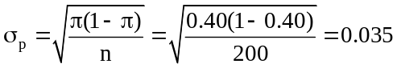
d.

8.26 p/a/m
a. E(p) = π = 0.40
b. 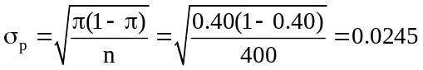
c.
d.
= 0.9793 - 0.2061 = 0.7732

8.27 p/a/m Let π = 0.20 of orders returned. Given n = 100, the distribution of p will be normal with
E(p) = π = 0.20 and 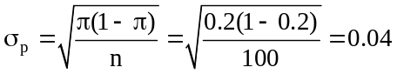
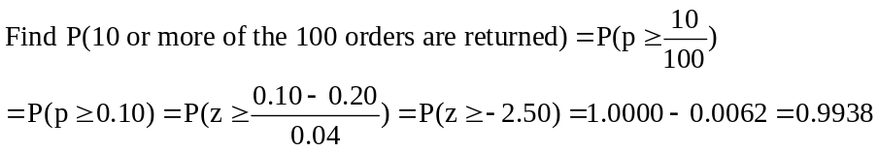

8.28 p/a/m With n = 50 and π = 0.58, the distribution of p will be normal. 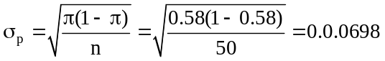
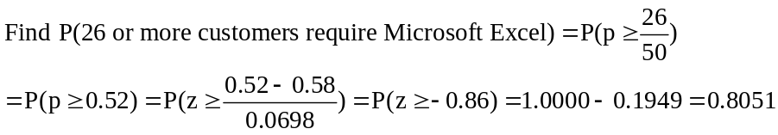
There is an 80.51% chance there will not be enough skilled Microsoft Excel people on hand.

8.29 p/a/d With E(p) = π = 0.05 and n = 400, 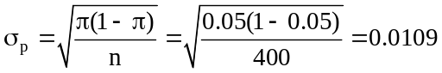
and the probability that at least 60 of the drivers would happen to be sick on a given day is
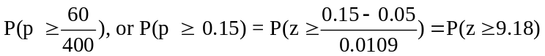, or 0.0000.
This is an incredibly large positive z value, far beyond the upper limits of our normal distribution table. The probability that such a large proportion of drivers would just happen to call in sick on a given day is, to four decimal places, 0.0000. The school district’s claim is much more credible.

8.30 p/a/d With E(p) = π = 0.034 and n = 600, 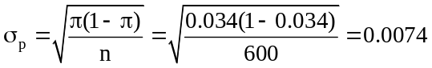
and the probability no more than 15 of the 600 items would be incorrectly scanned is
.
In these tests, Wal-Mart’s error rate was lower than the rate for the typical store, but there is a 0.1112 probability that such a small rate could have been due to chance variation, or sampling error. Thus, we should not reach a conclusion about the company based on these data.

8.31 d/p/m A finite population is one which is a set size; it is not infinitely large. In this case, we need to reduce the standard error for the sampling distribution. The larger the percentage of the population that is sampled, the smaller the sampling error will be.

8.32 d/p/m When the sample is at least 5% as large as the population, the finite population correction factor should be applied.

8.33 d/p/d The finite population correction factor will reduce the size of the standard error.
Whenever n < 0.05N, the correction will have little effect.

8.34 c/a/m Since n = 200, is approximately normally distributed by the central limit theorem
with μ = 1000 and 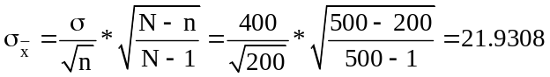

8.35 p/a/m Let = average income of the fund-raising group; is approximately normally distributed by the central limit theorem (since n = 30) with μ = 58,000 and
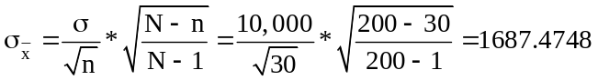

8.36 p/a/m With p = proportion of airports in the sample that are paved and lighted, n = 50, and
π = 132/217 = 0.6083, p will be approximately normally distributed since nπ = and n(1 - π) are
both ≥ 5.
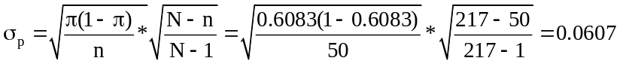
The probability that p will be ≥ 22/50, or ≥ 0.44, is

8.37 p/a/m Let p = proportion of defectives in the sample, n = 40, and π = 0.20; p will be approximately normally distributed since nπ and n(1 - π) are both ≥ 5.
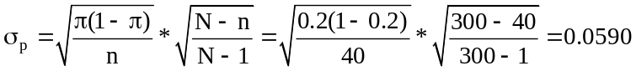

8.38 c/c/m The population is exponentially distributed with μ = 6 and σ = 6. The expected mean of the sample means is = 6. Because the population is not normally distributed and n is less than 30, we are unable to invoke the central limit theorem to determine 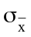. For 150 Minitab-generated samples, each with n = 2, the mean of the sample means is 5.950. This is fairly close to the expected value of 6.

Descriptive Statistics: xbar
Variable N Mean Median TrMean StDev SE Mean
xbar 150 5.950 5.087 5.640 4.125 0.337

Variable Minimum Maximum Q1 Q3
xbar 0.470 19.252 2.581 8.400

The histogram of sample means is nonsymmetrical and positively skewed.
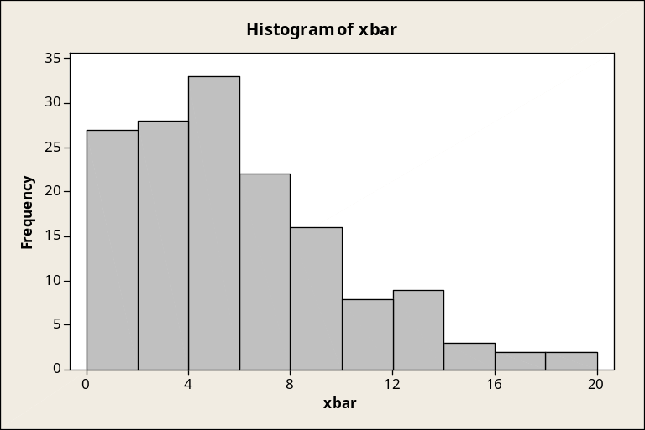

8.39 c/c/m The population is exponentially distributed with μ = 6 and σ = 6. The expected mean of the sample means is = 6. Although the population is not normally distributed, n = 30, and we can invoke the central limit theorem and the standard error of the sample means would be estimated as 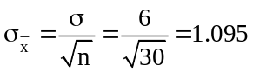. For 150 Minitab-generated samples, each with n = 30, the observed mean of the sample means is 6.0053. The standard error of the sample means is 1.1687. Both values are very close to their expected values.

Descriptive Statistics: xbar
Variable N Mean Median TrMean StDev SE Mean
xbar 150 6.0053 5.9447 5.9859 1.1687 0.0954

Variable Minimum Maximum Q1 Q3
xbar 2.9801 9.9940 5.3037 6.7290

With the larger sample size, the histogram of sample means is much more symmetrical, and approximately normal.
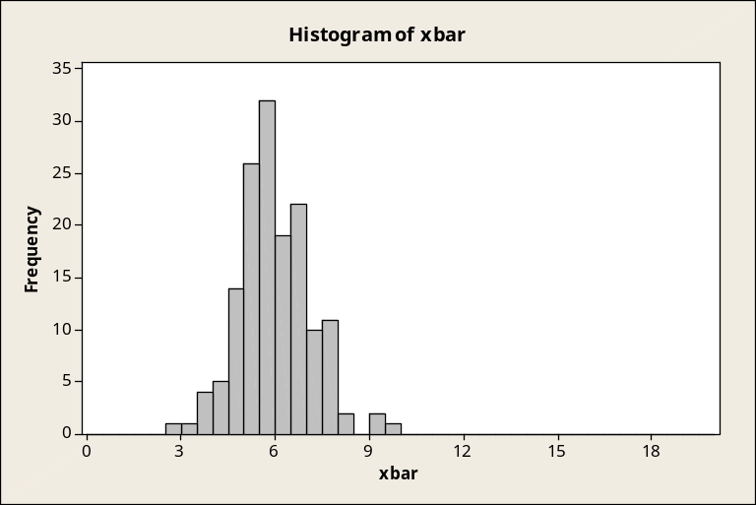

8.40 c/c/m The population is normally distributed with μ = 80 and σ = 20. The expected mean of the sample means is = 80. Although the samples are very small, the population is normal and we can estimate the standard error of the sample means as . For 150 Minitab-generated samples, each with n = 4, the observed mean of the sample means is 79.964. The standard error of the sample means is 9.167. Both values are very close to their expected values.

Descriptive Statistics: xbar
Variable N Mean Median TrMean StDev SE Mean
xbar 150 79.964 80.245 80.032 9.167 0.749

Variable Minimum Maximum Q1 Q3
xbar 56.405 104.841 73.989 85.798

The histogram of sample means is approximately normal, even with this small sample size.
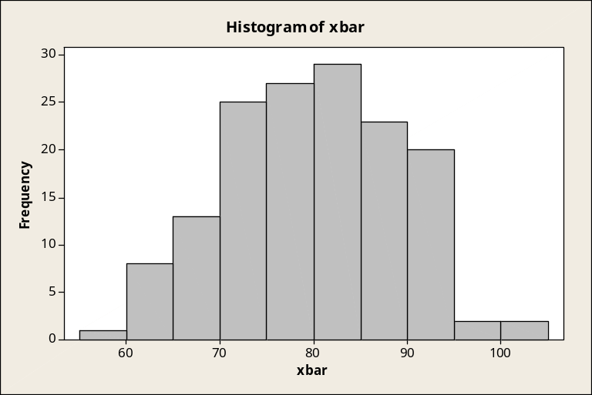

8.41 c/c/m The population is normally distributed with μ = 80 and σ = 20. The expected mean of the sample means is = 80. We can estimate the standard error of the sample means as 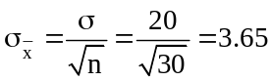. For 150 Minitab-generated samples, each with n = 30, the observed mean of the sample means is 79.921. The standard error of the sample means is 3.616. Both values are very close to their expected values.

Descriptive Statistics: xbar
Variable N Mean Median TrMean StDev SE Mean
xbar 150 79.921 79.800 79.881 3.616 0.295

Variable Minimum Maximum Q1 Q3
xbar 71.651 91.158 77.247 82.390

The histogram of sample means is approximately normal.
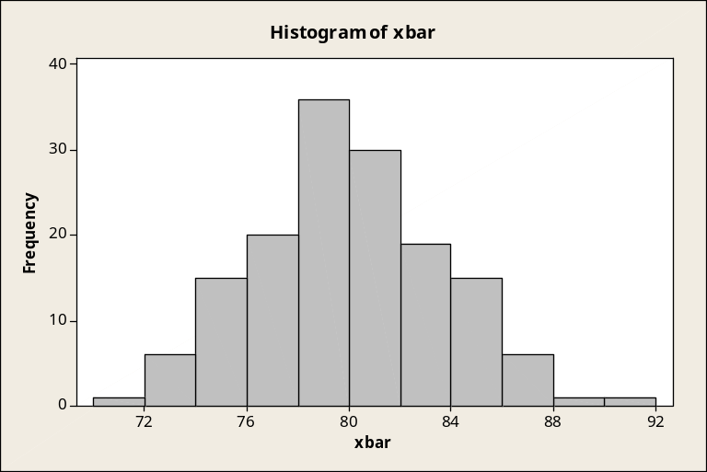

CHAPTER EXERCISES
8.42 p/a/m Let p = proportion of voters who favor the candidate; p will be approximately normally distributed with π = 0.55 and 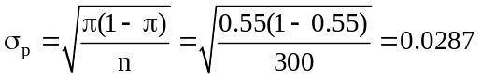 (assuming claim is true)

8.43 p/a/d From exercise 8.42, π = 0.55 and σ_{p} = 0.0287 (assuming the manager's claim is true.)
a. 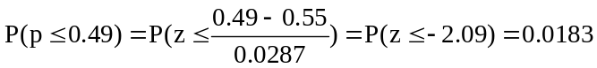
b. Since only 49% of the voters in the sample favored the candidate and the probability of no more than 49% favoring the candidate is just 0.0183 if the manager's claim is correct, the manager's claim is
probably not correct.

8.44 c/a/d
a. μ = 0(0.2) + 1(0.1) + 2(0.3) + 3(0.4) = 1.9
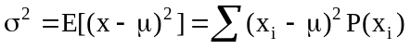
= (0 - 1.9)²(0.2) + (1 - 1.9)²(0.1) + (2 - 1.9)²(0.3) + (3 - 1.9)²(0.4) = 1.29 , and σ = 1.1358

b. and c.
sample | mean of this sample | probability of selecting this sample
0,0 | = (0 + 0)/2 = 0 | (0.2)(0.2) = 0.04
0,1 | = (0 + 1)/2 = 0.5 | (0.2)(0.1) = 0.02
0,2 | = (0 + 2)/2 = 1.0 | (0.2)(0.3) = 0.06
0,3 | = (0 + 3)/2 = 1.5 | (0.2)(0.4) = 0.08
1,0 | = (1 + 0)/2 = 0.5 | (0.1)(0.2) = 0.02
1,1 | = (1 + 1)/2 = 1.0 | (0.1)(0.1) = 0.01
1,2 | = (1 + 2)/2 = 1.5 | (0.1)(0.3) = 0.03
1,3 | = (1 + 3)/2 = 2.0 | (0.1)(0.4) = 0.04
2,0 | = (2 + 0)/2 = 1.0 | (0.3)(0.2) = 0.06
2,1 | = (2 + 1)/2 = 1.5 | (0.3)(0.1) = 0.03
2,2 | = (2 + 2)/2 = 2.0 | (0.3)(0.3) = 0.09
2,3 | = (2 + 3)/2 = 2.5 | (0.3)(0.4) = 0.12
3,0 | = (3 + 0)/2 = 1.5 | (0.4)(0.2) = 0.08
3,1 | = (3 + 1)/2 = 2.0 | (0.4)(0.1) = 0.04
3,2 | = (3 + 2)/2 = 2.5 | (0.4)(0.3) = 0.12
3,3 | = (3 + 3)/2 = 3.0 | (0.4)(0.4) = 0.16

d. Note: P(0.5) = 2(0.02) = 0.04 P(1.0) = 0.01 + 2(0.06) = 0.13
P(1.5) = 2(0.03) + 2(0.08) = 0.22 P(2.0) = 0.09 + 2(0.04) = 0.17
P(2.5) = 2(0.12) = 0.24

The sampling distribution of the mean (n = 2) is:
 | 0.0 | 0.5 | 1.0 | 1.5 | 2.0 | 2.5 | 3.0
P() | 0.04 | 0.04 | 0.13 | 0.22 | 0.17 | 0.24 | 0.16

= (0.0)(0.04) + (0.5)(0.04) + (1.0)(0.13) + (1.5)(0.22) + (2.0)(0.17) + (2.5)(0.24)
+ (3.0)(0.16) = 1.9
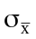² = (0 - 1.9)²(0.04) + (0.5 - 1.9)²(0.04) + (1 - 1.9)²(0. 13) + (1.5 - 1.9)²(0.22)
+ (2 - 1.9)²(0.17) + (2.5 - 1.9)²(0.24) + (3 - 1.9)²(0.16) = 0.645 and = 0.8031

8.45 p/a/m
a. Since n = 5 is less than 30, we would need to assume that the population is normally distributed in order to use the standard normal table to find P( < 170).

b. Let = the average fee for the 36 customers. Since n = 36 , is approximately normally distributed by the central limit theorem with μ = 187 and 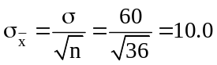.
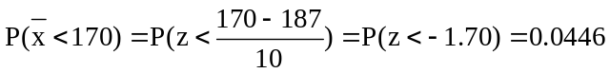

8.46 p/a/d Let = the average length of calls tomorrow in minutes, is approximately normally distributed by the central limit theorem (since n = 220) with μ = 2 and 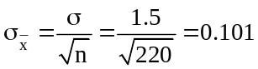.
Since Albert works 8(60) = 480 minutes and his quota is 220 calls, Albert will meet or exceed his quota if the average length of a call tomorrow is no more than 480/220 = 2.182 minutes.
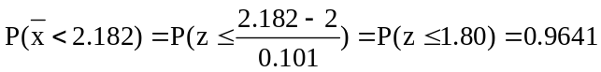

8.47 p/a/d Let = the average time to produce a unit; is approximately normally distributed by the central limit theorem (since n = 36) with μ = 25 and 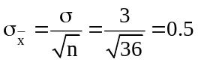.
a. When = 26.2, 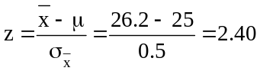
b.
c. When the machine is properly calibrated, the probability that the mean for a random sample of n = 36 will be at least 26.2 seconds is only 0.0082. Since this did occur, the machine is probably not properly calibrated.

8.48 c/a/d With 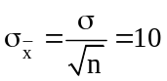: In order to cut in half, n would need to be 4 times as large.
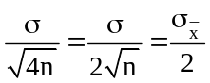

8.49 d/p/m In order to determine P( ≥ 220) when n = 5, we would need to assume that the population is approximately normally distributed. Since n is less than 30, the central limit theorem does not apply.

8.50 p/a/d = average seconds clock deviates from perfect time; is approximately normally distributed by the central limit theorem (since n = 40) with μ = 30 and
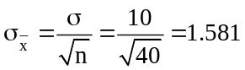 (assuming the manufacturer's claim is correct)
a.
b. Since the probability of obtaining a sample of 40 clocks with an average deviation from perfect accuracy of 34 seconds or more is only 0.0057 if the manufacturer's claim is correct, the claim is probably not correct.

8.51 p/a/d p will be approximately normally distributed with π = 0.20, and
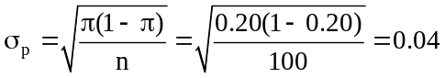
a. p = 10/100 = 0.10
b. 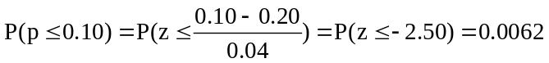
c. Since, if π is really 0.20, the probability of only making 10 sales out of 100 contacts is very small (0.0062), we would not accept Charlie's explanation that he "just had a bad day."

8.52 p/a/m Assuming that the cereal has a mean weight of μ = 12.2 and a standard deviation of σ = 0.40, the distribution of is normal with 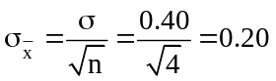.
It is highly unlikely for the average weight of four packages to be no more than 11.5 ounces.

8.53 p/a/m Let p = proportion of vehicles with a defect in the sample; p will be approximately normally distributed with π = 200/500 = 0.40 and
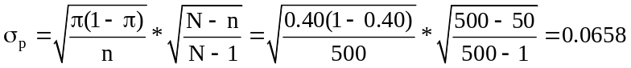

8.54 p/a/m Let p = proportion of registered voters who are Democrats; p will be approximately normally distributed with π = 0.70 and
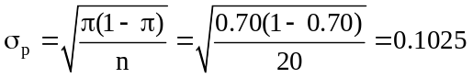
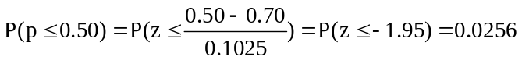

8.55 p/a/m Assuming that the distribution of completion times has μ = 38 minutes and σ = 5 minutes,
the distribution of is normal with 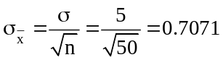.
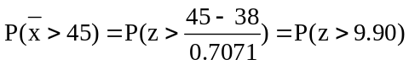
This is well beyond the limits of our printed standard normal distribution table. Using the computer,
we could verify that this probability (to four decimal places) is 0.0000.

8.56 p/a/m Let p = proportion of correct identifications in the sample of images; p will be approximately normally distributed with π = 0.50 and
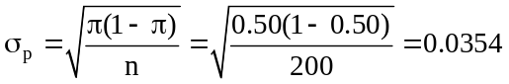
The proportion of successful identifications in the sample of 200 images is a little higher than 0.50,
but does not seem to be extraordinarily high. There is a 0.1292 probability that a proportion at least this high could occur simply by chance. It would not be a good idea for Donald to use these results as justification to get himself a listing in the yellow pages.

8.57 p/a/m Assuming that the distribution of bulb lifetimes is normal with μ = 2000 hours and σ = 100 hours, the distribution of is normal with hours.
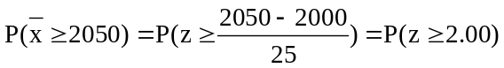= 1.0000 - 0.9772 = 0.0228
The probability is 0.0228 that the vendor will get the contract.

8.58 p/a/m Let p = proportion of graduates who pass the bar exam; p will be approximately normally distributed with π = 0.76 and
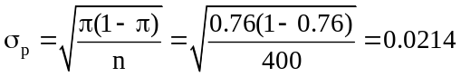
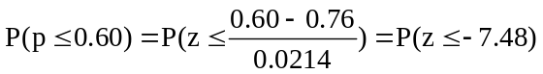= 0.0000
This is well beyond the limits of our printed standard normal distribution table. Using the computer,
we could verify that this probability (to four decimal places) is 0.0000. (Actually, Minitab expresses it to seven decimal places, 0.0000000.) If the graduates of this dean’s school really do have the same 76% pass rate as the population of those who take the exam, there is a 0.0000 probability that a sample of 400 would have a pass rate of 60% or lower. The dean’s explanation is not very credible.

INTEGRATED CASES

THORNDIKE SPORTS EQUIPMENT

Let = average weight of racquets in a sample; is approximately normally distributed by the central limit theorem (since n = 30) with μ = 240 and 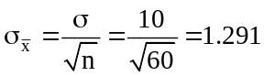.

Find the probability of the sample mean being at least this far from the assumed population mean for each of the samples that the worker took.

For the first sample:
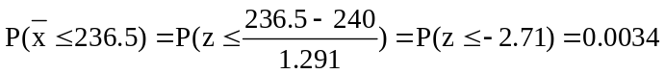

For the second sample:

We would thank the worker for his concern but tell him that the machine might still be producing racquets with an average weight of 240 grams. There is no reason to believe this has changed from the results of his samples, since some variability is expected. If the machine is still okay, the probabilities of these sample means occurring are quite small, but both of the sample means are within 3 standard deviations of the assumed population mean. Notice that one of the sample means is above 240 and one is below 240. Combining the two samples, the overall sample mean is 239.8 (n = 60), which is quite close to the assumed population mean of 240.

The nature of the population distribution and its standard deviation is another matter, however.
If the output of the machine is really normally distributed with a mean of 240 grams and a standard deviation of 10 grams it would be extremely unusual to get two samples in a row in which the sample means are so far away from 240 grams. The machine may have “loosened up” over the years.

